

KB Blacklist

In an attempt to thwart ever increasing malicious behaviour online and the associated risk of fraud, we have created new functionality called KB Blacklist that allows you to dynamically restrict access to your ecommerce solution.

KB Blacklist works by allowing site owners to configure the rules regarding which connections are prevented from accessing the site or completing transactions, including touts.

This restricts opportunities for hackers to attempt to execute brute force attacks and upload malware as well as preventing known fraudsters and touts from completing transactions.

KB Blacklist can be installed on your existing ecommerce solution. Once this has been configured, you can control access to the site without ever needing to edit your website logic nor make any firewall changes.

The powerful blacklisting capabilities provide strong protection against touts and other unwelcome business, malicious bots sniffing for vulnerabilities and severely thwarts scripted, automatic website attacks.

This functionality can be exposed via a public API so you could also use this to protect your existing CMS solutions from attack as well if you wanted to.

Here is a brief summary of the functionality and how it works.
KB Blacklist Setup

You control the creation of blacklists by adding, deleting or editing the settings from a management control page for each type of blacklist.

This back office management setup can be added to your existing ecommerce solution with anonymous access turned off. That way, only authorised users can control the blacklist setup plus this can be maintained from anywhere, not just the Box Office or IT Department.

We currently support six different types of blacklists and restrictions. We can easily add additional types if necessary.

The currently supported blacklisting types are as follows.

- Email Address Blacklist: Users login email address.

By blacklisting a users email address, that user is then unable to use that email address to login to the website nor are they able to use that email address on their customer record (ie to save where they would want booking confirmation notifications to be sent).

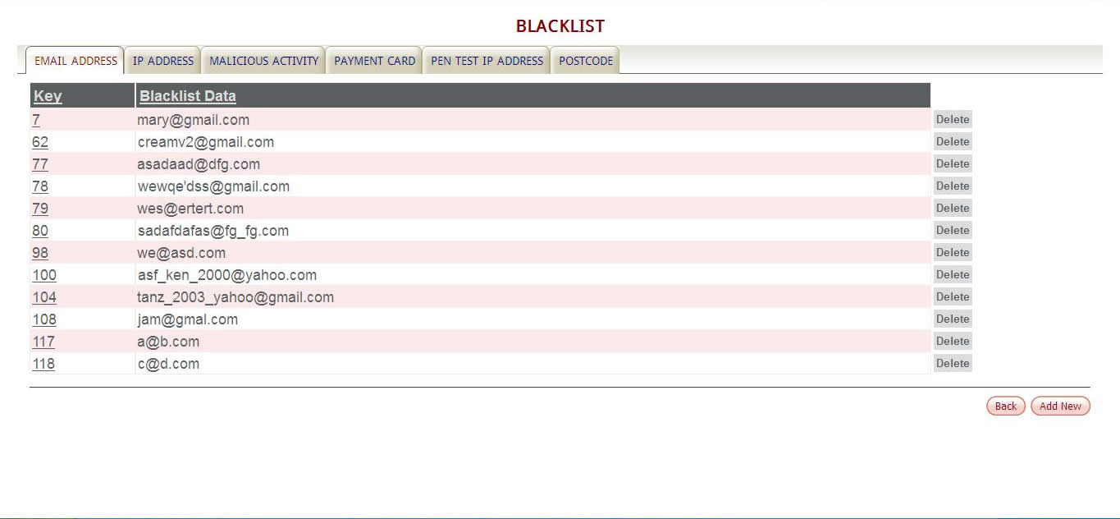
Figure 1 Email Address Blacklist

- IP address Blacklist: IP address of the machine being used to access the website

By blacklisting an IP address you can stop all ecommerce access from that users machine. This is particularly useful when a users machine has been compromised by malware and the user is unaware that their PC is being used to attack your website.

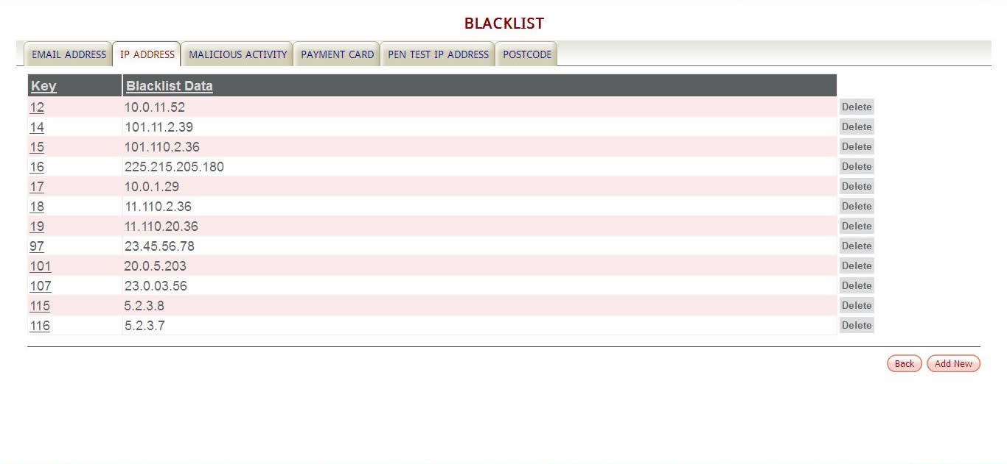
Figure 2 IP Address Blacklist

- Pen Test IP Address White List: White listing penetration test performer companies

Many sites now commission 3rd party penetration test providers to scan their websites for potential vulnerabilities. The premise being that the authorised 3rd party can then provide secure audits and offer guidance regarding how to best configure the architecture of the ecommerce solution. Because the techniques used by 3rd party penetration test providers are identical to those used by hackers we support the ability to white list these companies. That way, when they are running their tests, we do not automatically block them nor send 404’s.

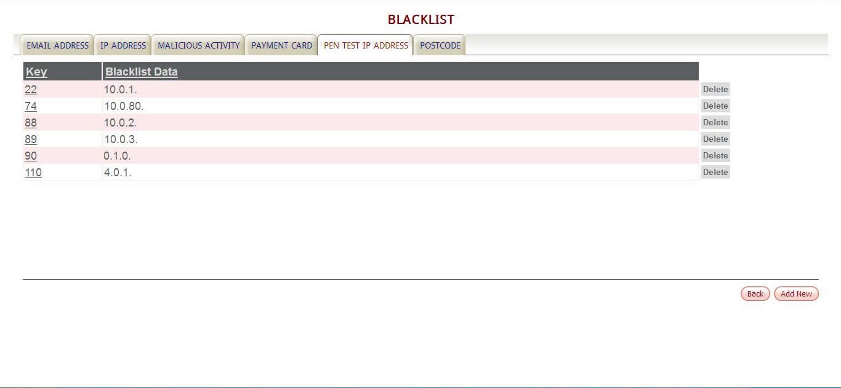
Figure 3 Pen Test IP Address White List
- Postcode Blacklist: Users postcode

By blacklisting a postcode, you prevent a user from having tickets sent out to a specific address. The postcode blacklist supports postcode and house number. This is useful for thwarting touts and other unwelcome customers.

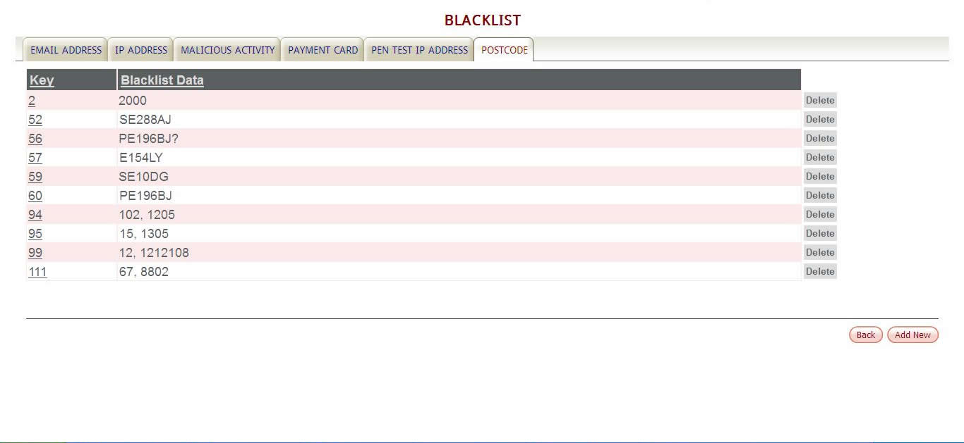
Figure 4 Postcode Blacklist

- Card Number Blacklist: Users credit or debit card number

By blacklisting specific credit card numbers you can effectively add known hot cards or regular valid cards from being used on the site. This is useful for thwarting touts and other unwelcome customers when the card is legitimate but the business unwelcome.

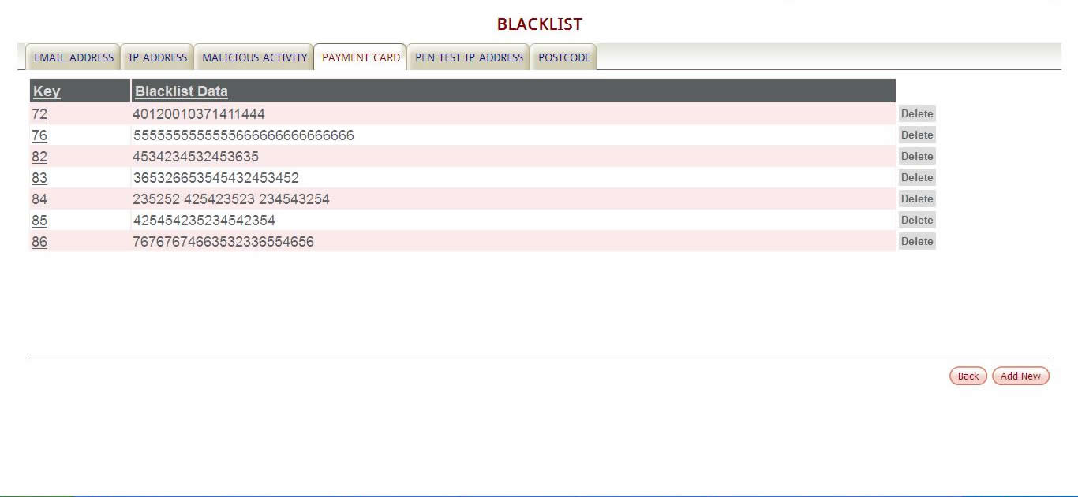
Figure 5 Payment Card Blacklisting

- Blacklisting Malicious Activity: Monitoring unwanted files

Most hackers use automated bots that scan for website vulnerabilities. These vulnerabilities are often publicly announced or known about prior to infrastructure vendors being able to issue patches for them. Typically a hacker will use an automated process that executes a large number of invalid or malformed requests that probe the website for known weaknesses.

KB Blacklist allows you to store these known requests so that any time a user tries to execute any one of them, their website session gets immediately terminated and their IP address automatically blacklisted. This prevents the remainder of their script executing and stops that machine from accessing your website until you decide to release it. Often users are completely unaware that their machine is infected with malware and being used for these malicious purposes without their knowledge.

This feature of KB Blacklist is very powerful as it means you do not need very expensive hardware to vet and sanitise all incoming ecommerce connections requests.

KB Blacklist comes pre-populated with a large number of known automated malicious bot requests based on our experience of watching the failed requests generating missing page notifications (404’s) on our ecommerce solutions over the last decade.

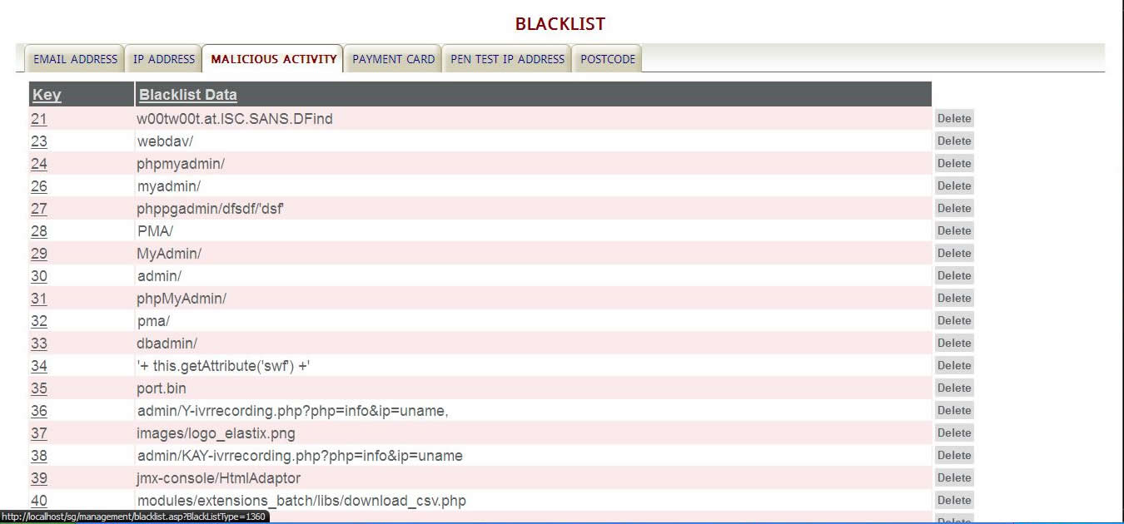
Figure 6 Malicious Activity

KB Blacklist User Presentation

The following screen shots show how you would set up a specific blacklist via the blacklist back office maintenance forms and how the result of that process gets presented to the user.

All the error messages that get presented to users are configurable and can be modified as required.

IP Address Blacklist Setup and User Presentation

These screen shots show the IP address set up within KB Blacklist.

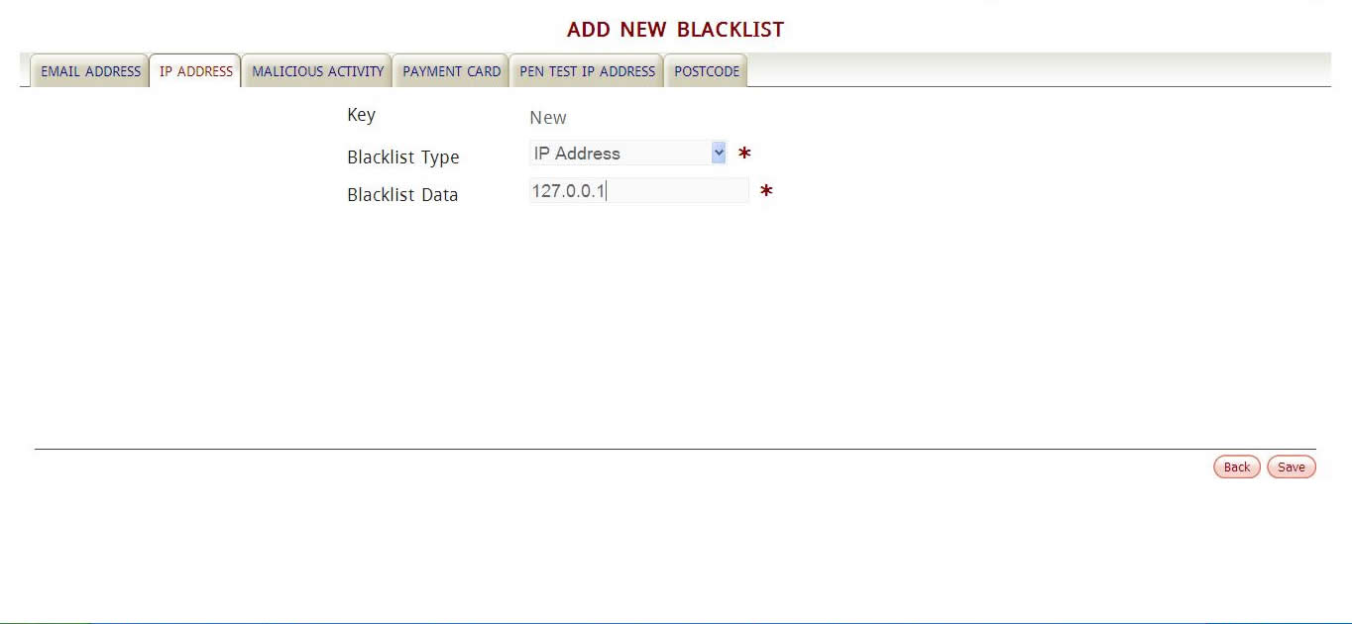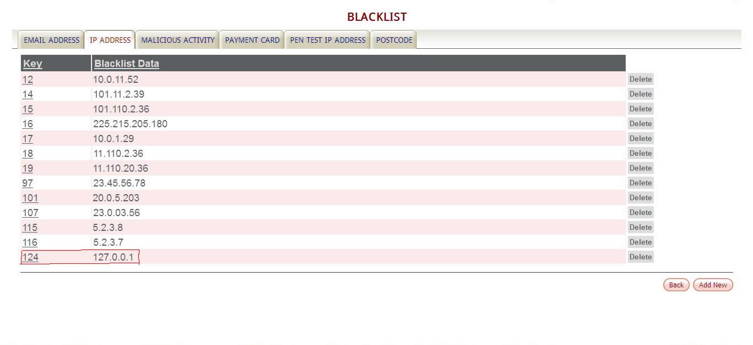
Figure 7 IP Address Blacklist Setup

This screen shot shows the error message that the user would get when tried to access your website with a blacklisted IP address.

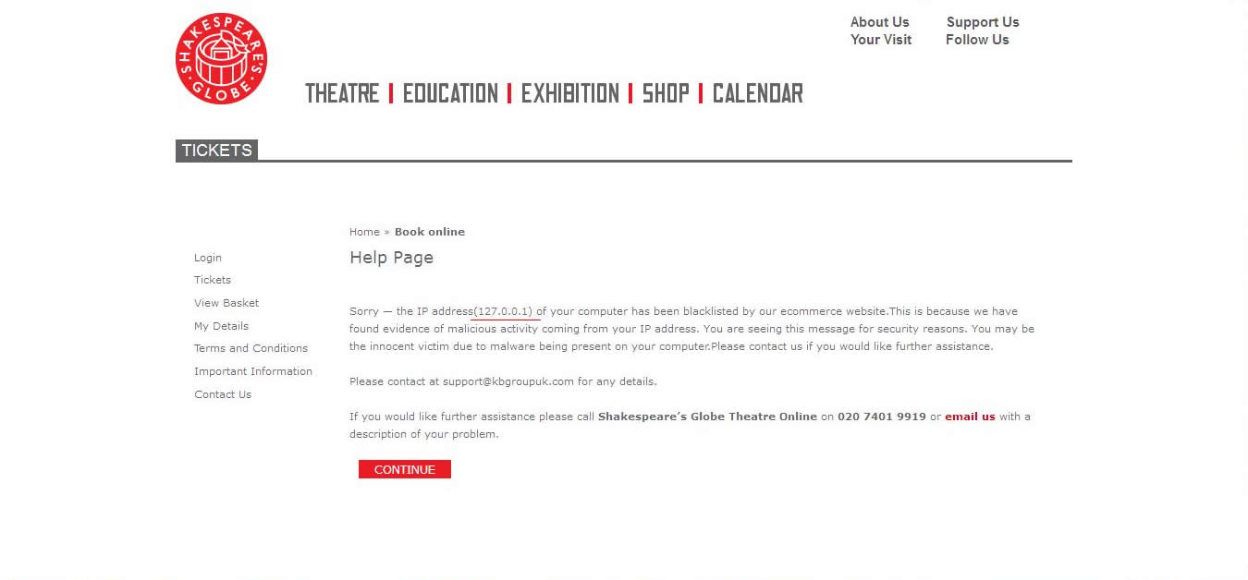
Figure 8 Blacklisted IP Address Message

Email Address Setup and User Presentation

Here is the setup for the login email address.

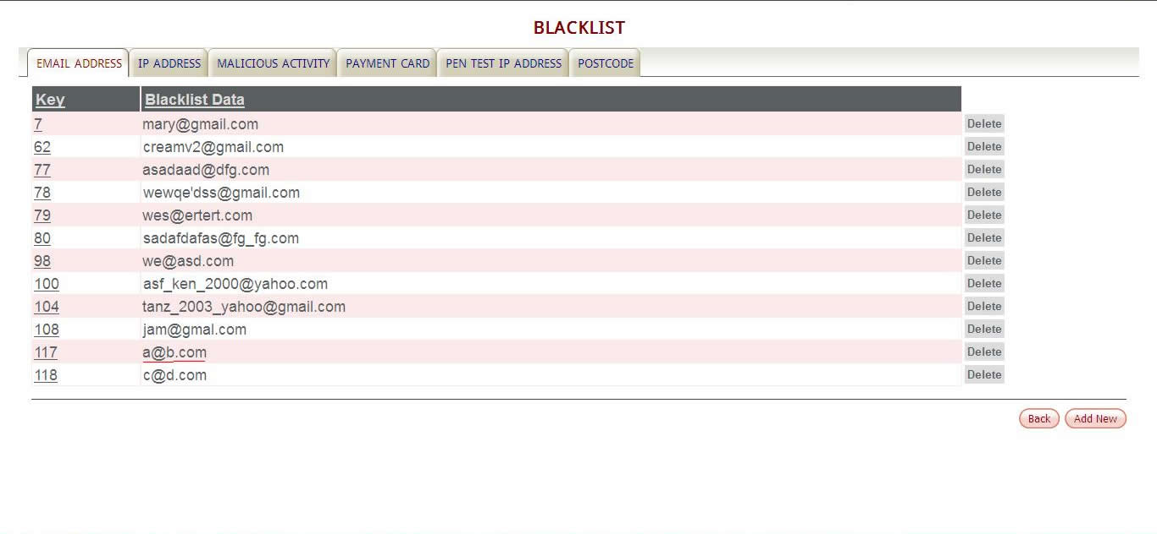
Figure 9 Blacklisted Email Address List

This screen shot shows the error message that the user would get when tried to register or login using this blacklisted email address.

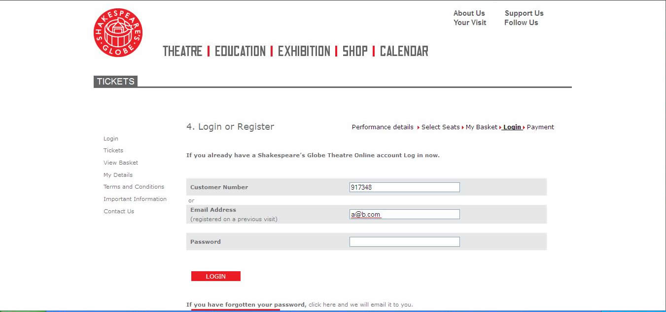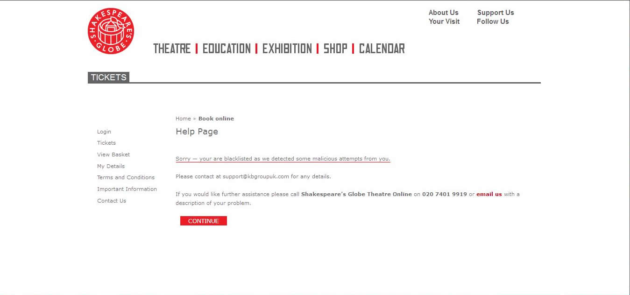
Figure 10 Blacklisted Email Address Message

Postcode Blacklist Setup and Presentation

Here is an example list of blacklisted postcodes.
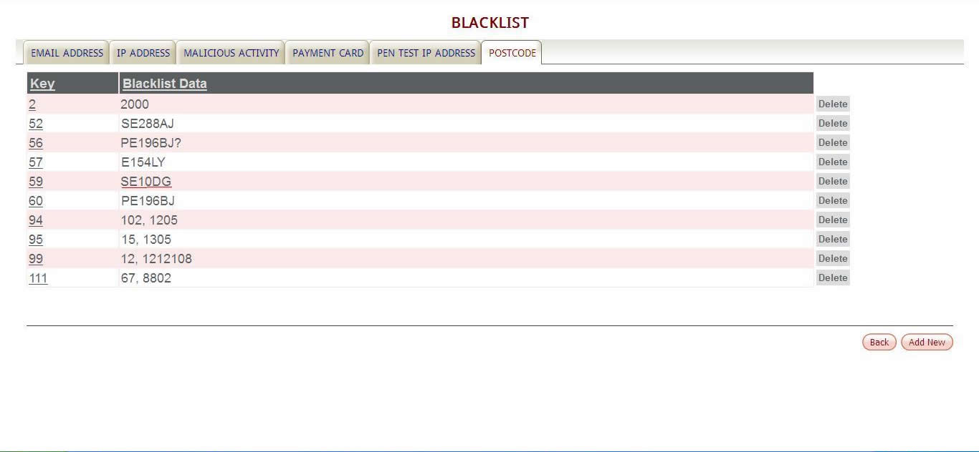
Figure 11 Blacklisted Postcode List

A user cannot register or update their personal contact details if their address and house number have been blacklisted:

This screen shot shows the user entering blacklisted address credentials.

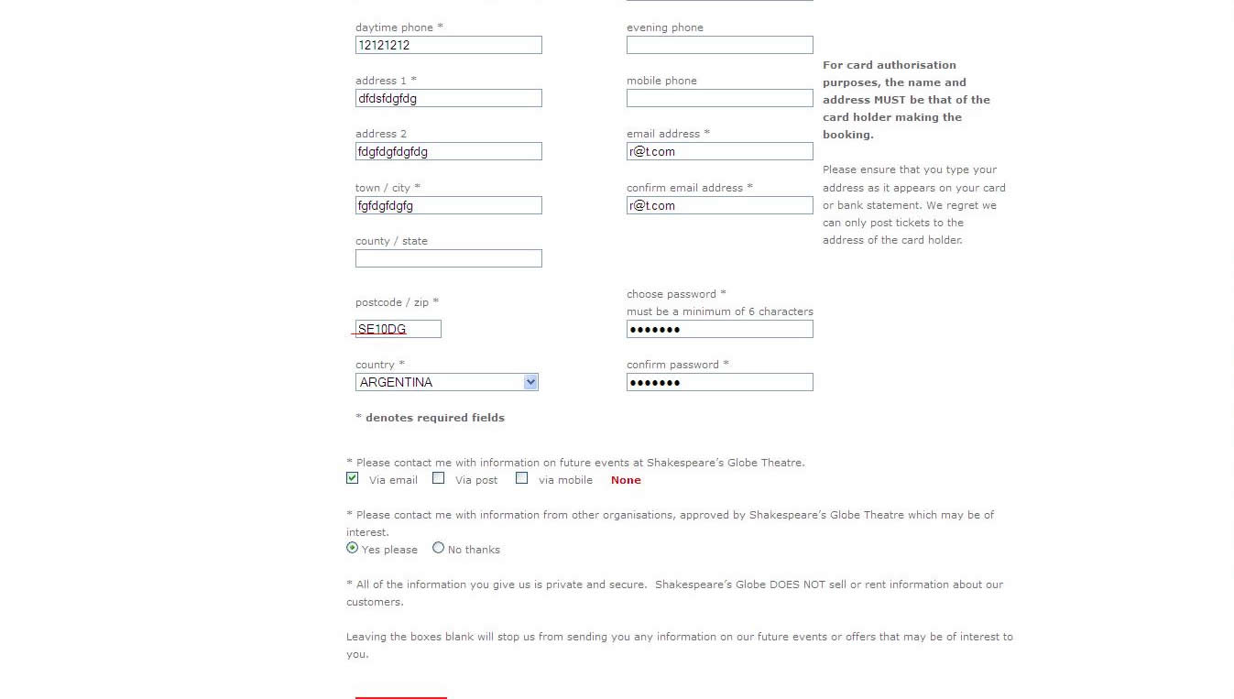
Figure 12 User Registration with Blacklisted Postcode

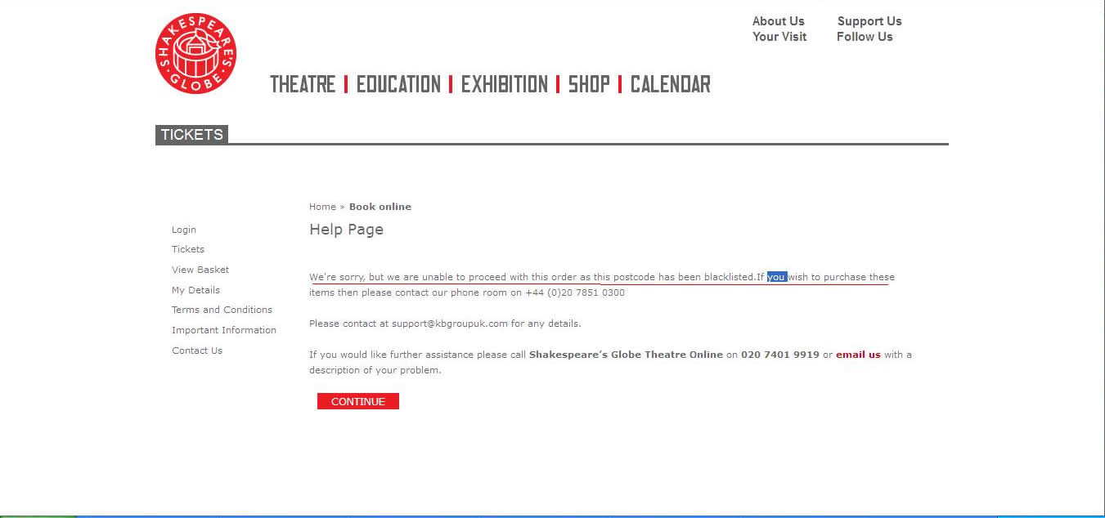
Figure 13 Blacklisted Postcode Message

Blacklisted Credit Card Setup and User Presentation

You can also block unwanted credit card numbers by adding these to the black list. These may not necessarily be stolen cards. They could be cards from third parties, such as touts, for whom you do not wish to transact with.

By blocking the users IP address, their email address, their physical delivery address and their payment cards, you make it significantly more difficult for them to purchase from you. The net outcome is that take their unwelcome business somewhere else.

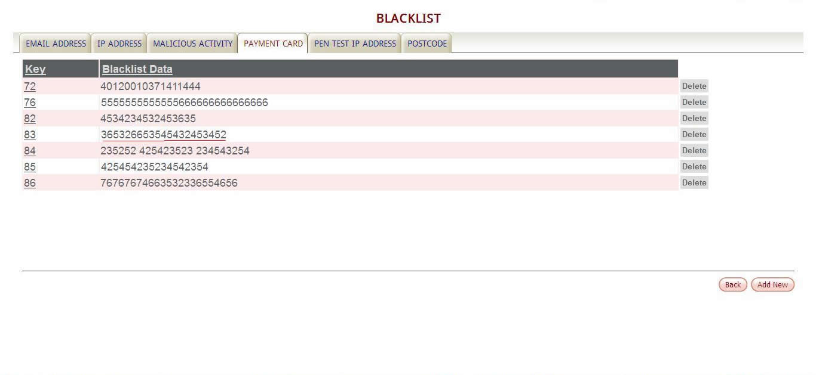
Figure 14 Blacklisted Payment Card List

During the card payment process at the ecommerce checkout, if the user attempts to complete the transaction using one of these blacklisted card numbers, then they get presented with the following message and cannot proceed any further.

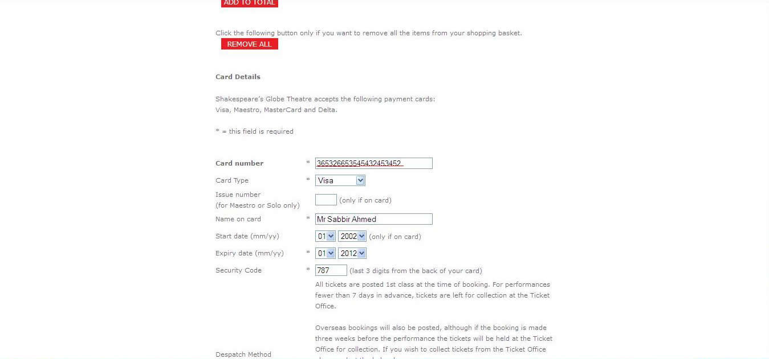
Figure 15 Entering Blacklisted Card Details

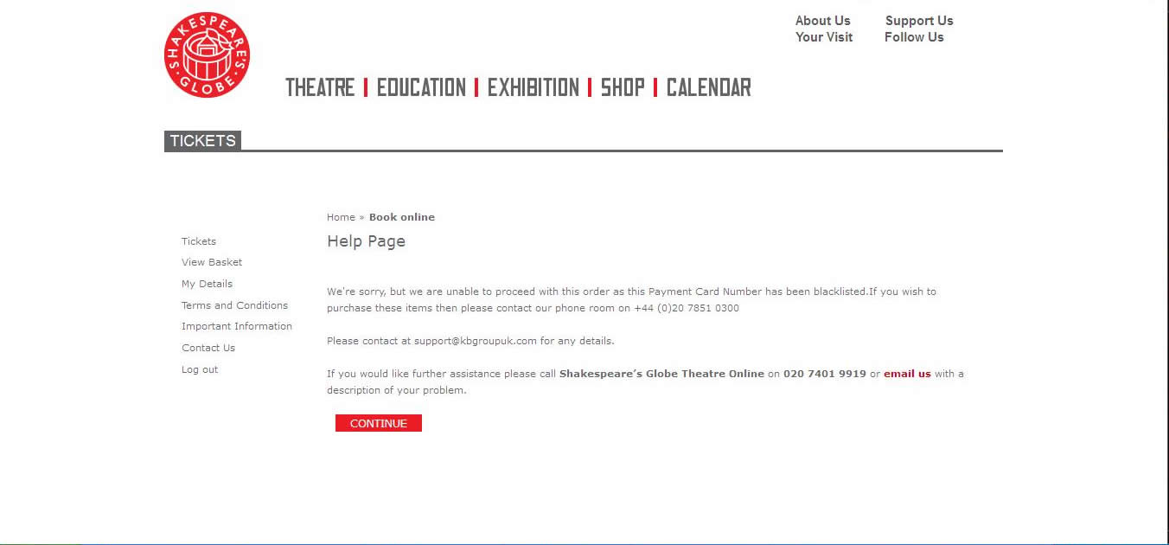
Figure 16 Blacklisted Card Transaction Failure Message

