

Table of Contents

1. Contact Us | … 03
2. What is KB Email Suite? | … 04
3. KB Clean Mail Features | … 05
4. Customer Comments | … 06
5. How do I install KB Clean Mail? | … 07
6. How do I use KB Clean Mail? | … 12
6.1 Invoke KB Clean Mail from the Windows start menu | … 13
6.2 Do a one off database configuration | … 14
6.3 Process your mailbox | … 18
6.4 Update Failed Email | … 22

1. Contact Us

The primary contact at KB Group for KB Clean Mail is:

Simon Klinkhamer
KB Group (UK) Ltd
69 Mildmay Road
London
N1 4PU

Telephone: 020 7254 7256
Mobile: 07931 751 227
Email: simon@kbgroupuk.com
Web: www.kbgroupuk.com

2. What is KB Email Suite?

KB Email Suite is a family of products, which enable businesses to manage the complete life cycle of all customer marketing and relationship correspondence.

The KB Email Suite is a unique product as unlike all other bulk email packages currently available there is no fee per email. Instead there is a one off cost for purchasing each component of the KB Email Suite and a yearly support charge which provides all upgrades as well as product support. The components can be used either together or on their own with each component available to purchase individually if preferred.

The KB Email Suite is comprised of 3 solutions.
- KB Bulk Mail
- KB Clean Mail
- KB Affiliate Tracker

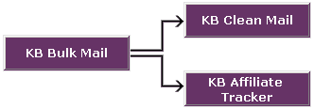

3. KB Clean Mail features
KB Clean Mail cleans up any invalid email addresses that have been returned as undeliverable.
- Cleans up your email address list source so that subsequent campaigns have fewer failures
- Cleans up invalid emails that have been returned as undeliverable
- Detects and reports out of office emails
- You can load any email folder (public or personal) to clean up the returned mail
- You can import email addresses, notes and contacts
- You can validate email address
- You can validate domain addresses
- You can update your Back Office system with updated email address information
- KB Clean Mail contains optimised logic for fast processing of high volumes

4. Customer Comments

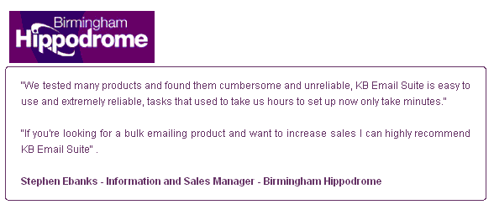

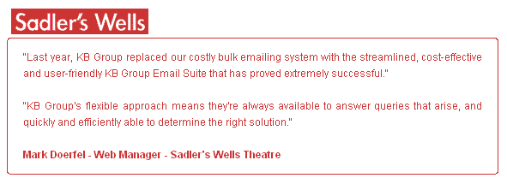

5. How do I install KB Clean Mail?

It is recommended that you close any applications you may be running before installing KB Clean Mail.

- KB Group will send you a zip file that contains the software

- Unzip the file

- Double click setup.exe

- The setup.exe will install the KB Clean Mail software and create a Microsoft Access database

- Below is the first screen that will appear after you click setup.exe.

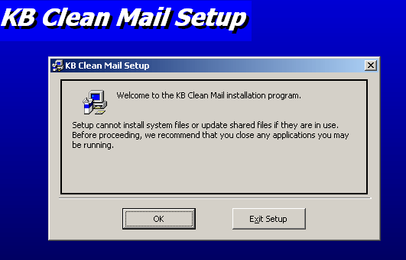

- Press the OK button to continue

- The setup will automatically install KB Clean Mail in c:\Program Files\KB Clean Mail\. If you are happy with the default directory then press the computer icon 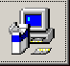 button. If you want to change this directory then press the Change Directory button.

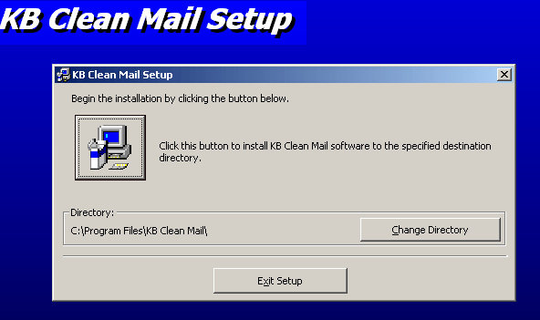

- The setup will automatically create a KB Group Program Group (this is the name of the menu item in your windows menu Start->All programs->…). If you would like the menu item to be called something different simply change the name in the Program Group box.

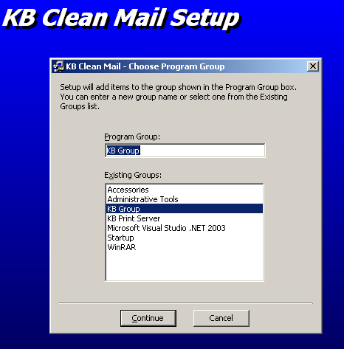

- Press the Continue button to continue

- The setup program will now install the KB Clean Mail files.

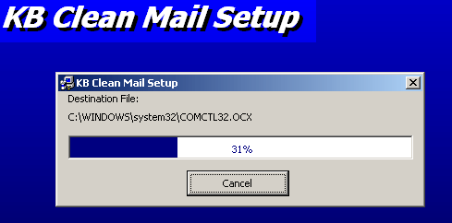

- The following message may appear a few times when the setup is installing the individual files. If you receive this version conflict message then this means that a file on your computer is newer than the one being installed. Always keep the original file by choosing the Yes button.

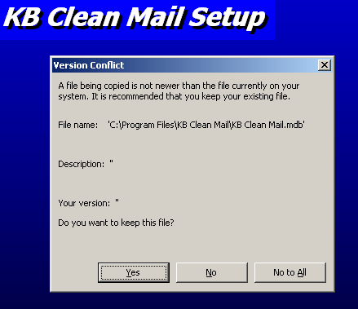

- If the KB Clean Mail was setup successfully, the following will appear.

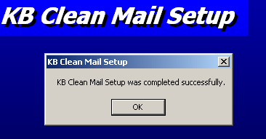

6. How do use KB Clean Mail?

After successfully installing KB Clean Mail, use the steps below as a guide of how KB Clean Mail works. The following pages describe each of these steps in more detail.

- Invoke KB Clean Mail from your Windows Start menu

- Do a one off database configuration setup

- Process your mailbox

- Update failed/bounced back email addresses

6.1 Invoke KB Clean Mail from the Windows Start Menu

- Choose Start->All Programs->”your KB Email Suite program group” from your Windows Start Menu.

- The following KB Clean Mail screen will appear.

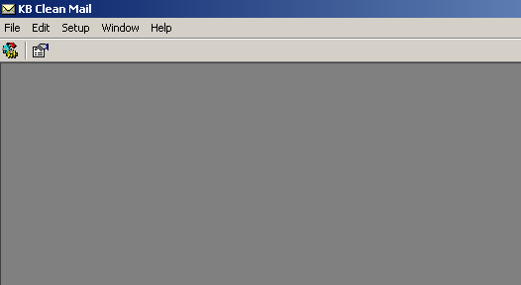

6.2 Do a one off Database Configuration

The Locate Application Databases screen allows you to change the location of your KB Clean Mail Access database and to select the back office eticketing database that contains your email addresses. You need to select the back office database so that KB Clean Mail knows which database to update when it modifies invalid emails.

- From the menu bar choose Setup then Database Configuration.

- The following Locate Application Databases screen will appear.

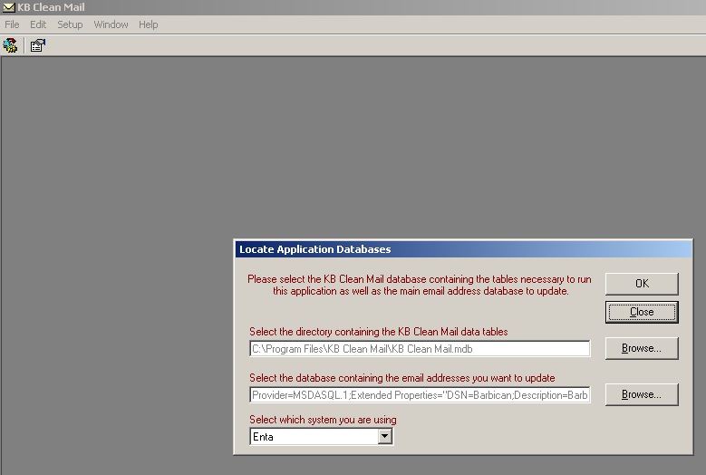

Select the directory containing the KB Clean Mail data tables

When KB Clean Mail is installed it creates the KB Clean Mail Access (.mdb) database in the directory where the application was installed, typically c:\Program Files\KB Clean Mail. This location is fine for most installations. However if you have multiple KB Clean Mail installations you may prefer to have them all use the one central Access database. Use the Database Configuration to set this up.

Select the database containing the email addresses you want to update

- Press the Browse button. The following Select Data Source screen will appear.

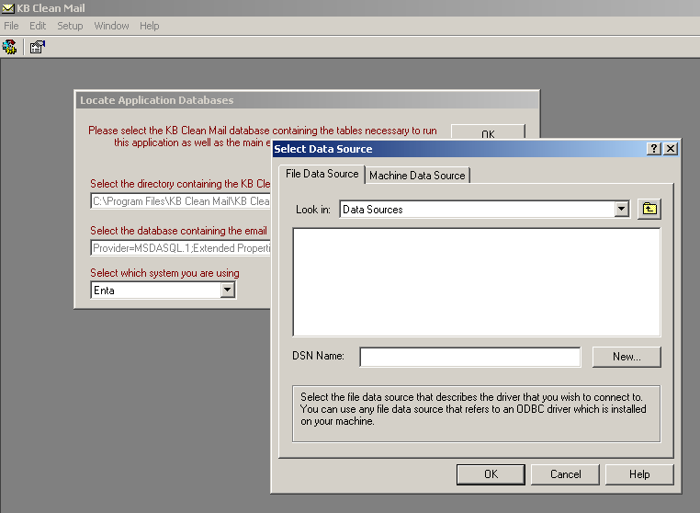

- Press the Machine Data Source tab. The following Machine Data Source screen will appear.

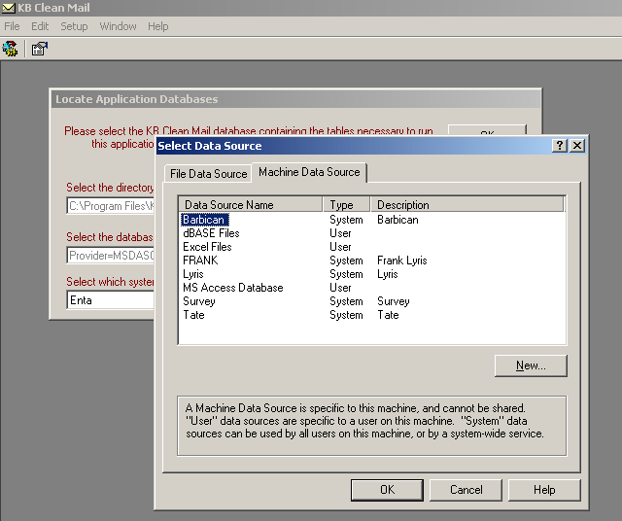

- Select the row containing the name of your back office eticketing system. Contact your system administrator if you are insure about what information to use here. In the example above the Barbican has been selected.

- Press the OK button. The following SQL Server Login screen will appear.

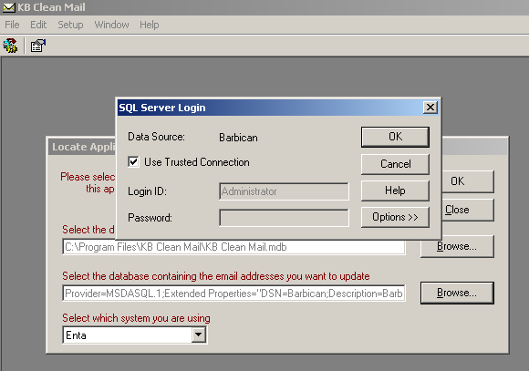

- The Use Trusted Connection check box stays ticked.

- Press the OK button. The Locate Application Databases screen SQL Server Login screen will appear.

Select which system you are using

- Choose your appropriate back office eticketing system.

- Press the OK button.

6.3 Process your Mailbox

Process your mailbox allows you to upload all of the bounced back emails from the mailbox you used for your email campaign.

- From the menu bar choose File then Process Mailbox…

- The following Select Mail Box or Contacts to Process screen will appear.

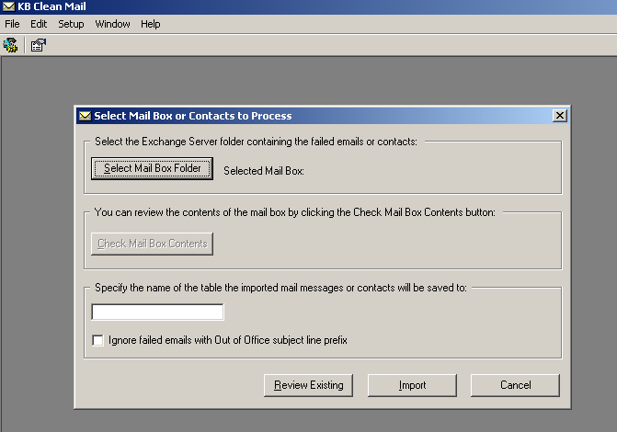

- Press the Select Mail Box Folder button. The Select Folder screen will appear

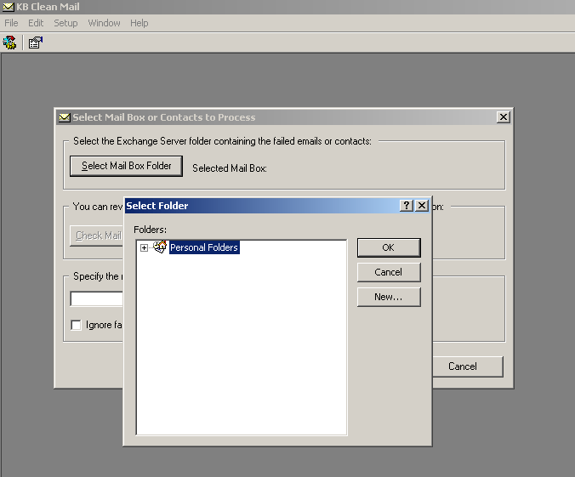

The Personal Folders above is an example; you may have different folder names.

- Press the + button to navigate through your folders until you locate the mailbox that sent our your email campaign. Contact your system administrator if you cannot locate your mailbox.

- Press the OK button. The Select Mail Box or Contacts to Process screen will reappear with your chosen mailbox name beside Selected Mail Box.

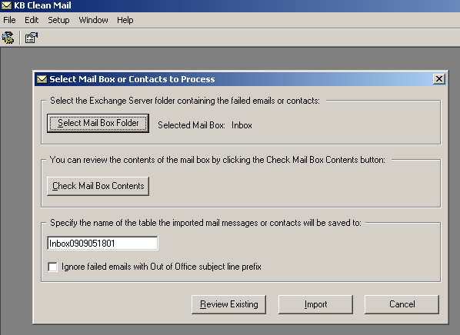

- If you would like to review the contents of your selected mailbox then press the Check Mail Box Contents button. The Microsoft Outlook screen will display, to exit this screen press the x button.

- KB Clean Mail automatically generates a file name for the table to import your mailbox into. Change this name if it’s not appropriate.

- If you don’t want to import Out of Office emails then click this box.

- You are now ready to import your mailbox. This process will import all the emails or contacts from your selected folder into the KB Clean Mail database. It may take some time to process based on the number of records. Press the Import button to import your selected mailbox into your table.

- The following Microsoft Outlook Warning screen will appear. This warning screen is a built in Microsoft security feature that has detected that someone is accessing your email. That someone in this case is the KB Clean Mail program.

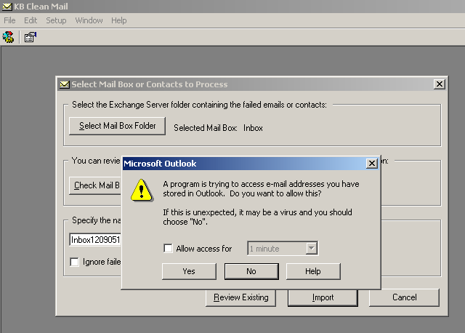

- In order for the KB Clean Mail to process your mailbox, you need to click the “Allow access for 1 minute” box. This is a security feature of Outlook, which protects unauthorised access to your mailbox.

- Press the Yes button to import your mailbox.

- The following Update Email Addresses screen will appear. It displays the contents of your selected mailbox with the email addresses extracted.

6.4 Update Failed Email Addresses

You can access the Update Email Addresses screen via:
- The steps in “9.3 Process Your Mailbox”
Or
- From the menu bar choose File then Process Mailbox…
- Press the Review Existing button to import your mailbox
- The following Imported Mail Box List screen will appear

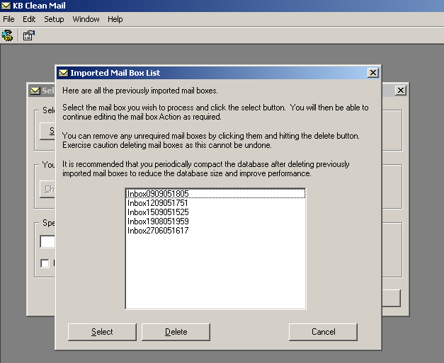

The Imported Mail Box List screen allows you to:
- Review/edit previously imported mailboxes. Highlight the mailbox you wish to review and press the Select button. The Update Email Addresses screen will appear.

- Remove unrequired mailboxes. Highlight the mailbox you wish to remove and press the Delete button.

The Update Email Addresses screen contains ‘bounced back’ emails from your campaign. The Update Email Addresses screen allows you to fix the failed email addresses in your Back Office ticketing system via KB Clean Mail.

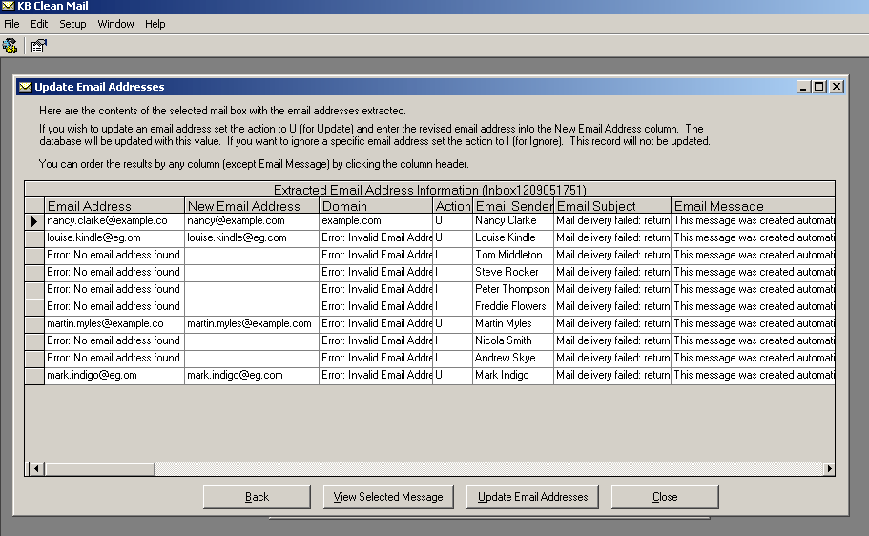

- Highlight the row you want to correct. Please note, you can only correct emails where an email address exists in the Email Address column. If there is no email address in this column or if there is an error message it means that the import process couldn’t detect what the failed email address was. The import program looks at the contents of each failed email for the email address. You can press the View Select Message button to find the failed email address yourself and then update it manually in the Email Address column.

- Enter the correct email address in New Email Address column

- Set the Action column to U (update) for email addresses you want to update or I (ignore) for the email addresses you don’t want to update.

- Keep repeating the process above until you are ready to update your Back Office ticketing. You can update as many times as you like

- Press the Update Email Addresses button. The following box will appear informing you that this process will update your Back Office ticketing system with the selected email addresses. It may take some time based on the number of records.

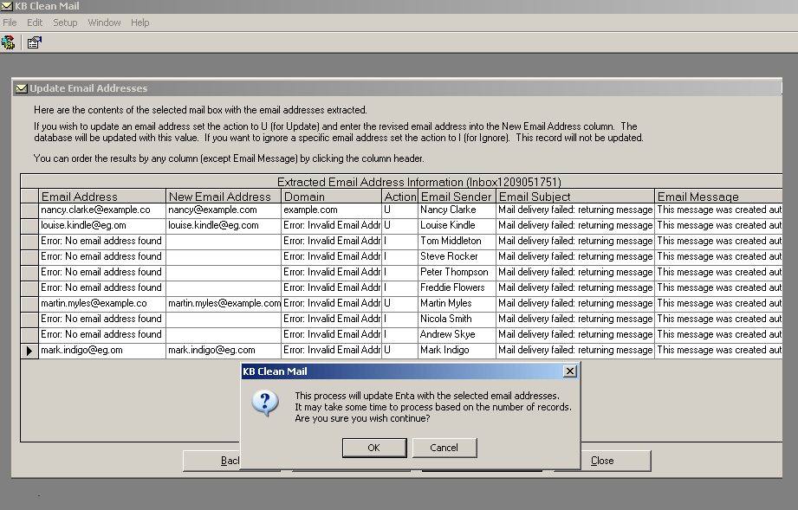

- Press the OK button to continue.

