KB Refund Screen Shots

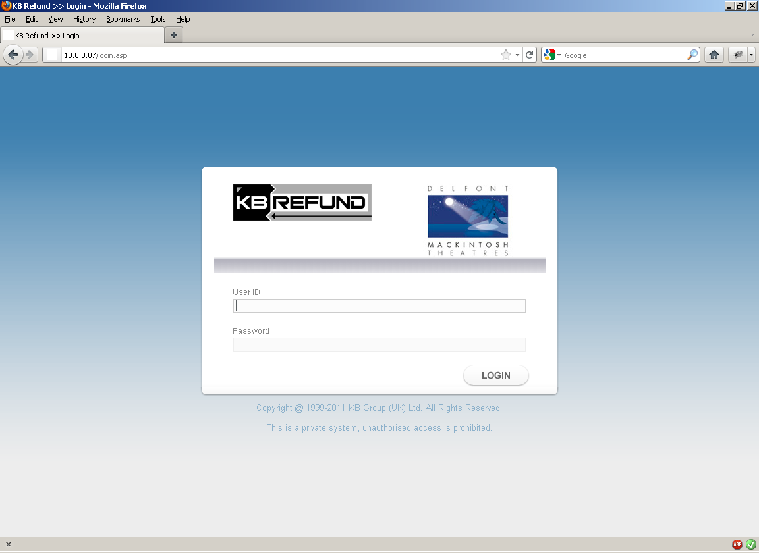
Figure 1 KB Refund Login

The user logs in with their Enta login credentials. In addition, the user must be explicitly added to KB Refund as a valid User login by the Administrator before they can login.

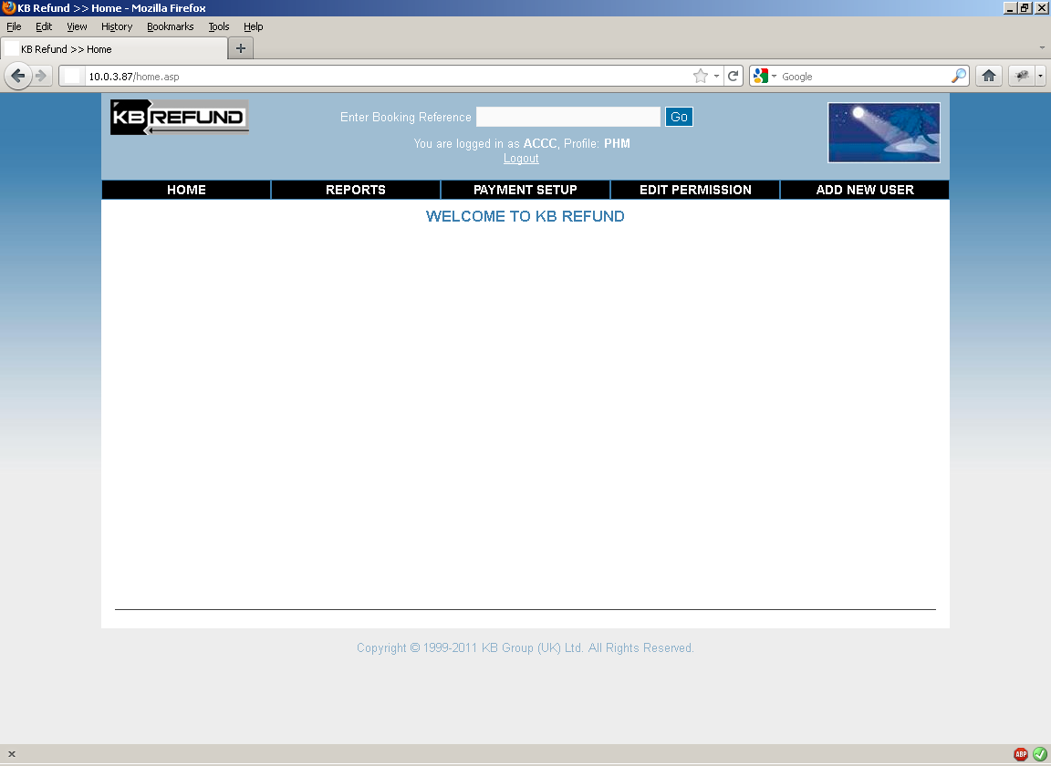
Figure 2 Main KB Refund Screen

This is the main KB Refund screen. Here users can navigate the various options.

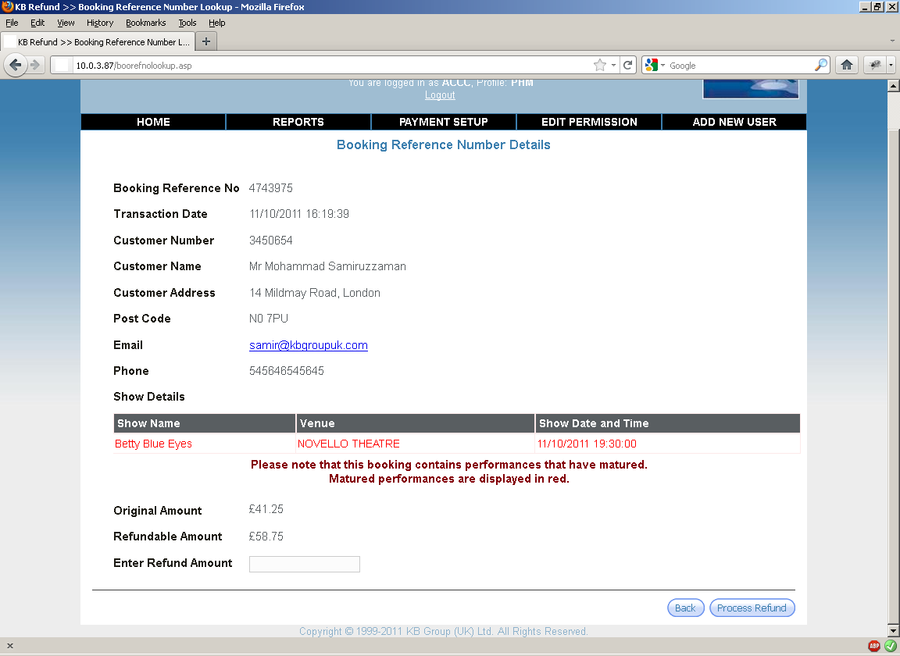
Figure 3 Main Booking Refund Screen

By entering a valid booking reference in the top bar, the following booking summary screen is presented.

The Process Refund button will only appear if the booking has an amount due (ie the booking is now overpaid due to cancelled booking lines).

The User enters the refund amount (this must be the same or less than the refundable amount – ie the amount due on the booking) and clicks the Process Refund button.

YESpay then does the refund, and the requisite booking payment lines are added to Enta. If the full amount due is refunded, then the booking will now balance in Enta.

Multiple refunds can be made against a single booking as long as there is an amount due.

All refunds are made against the same card that the payment was made from. If that card has expired or is no longer valid then the refund will fail.

The application is fully PCI compliant as no card details are ever displayed or used. All transactions are completed using the YESpay PGTR identifier.
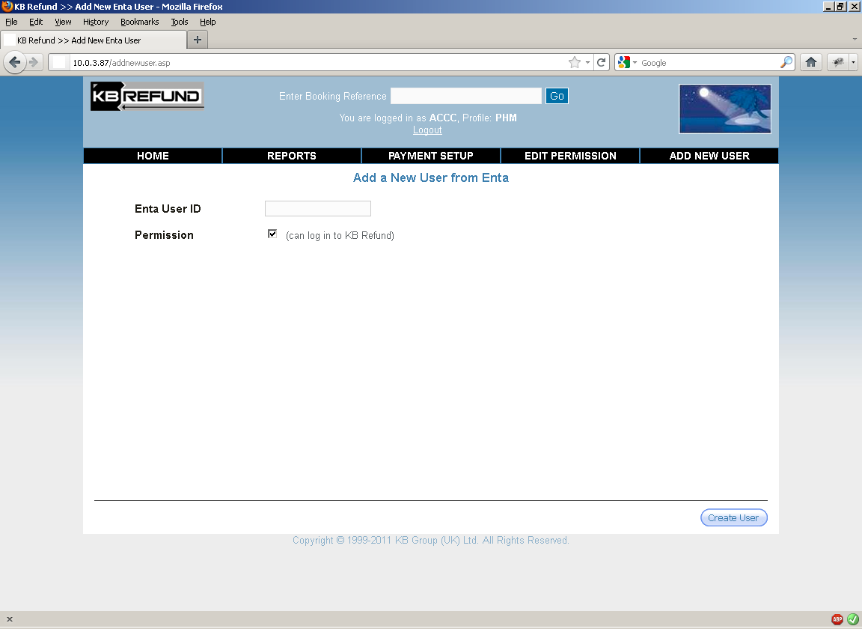
Figure 4 Add New User

In addition to having a valid Enta login, the user must be explicitly added to KB Refund. This is to restrict unauthorised access to doing refunds.

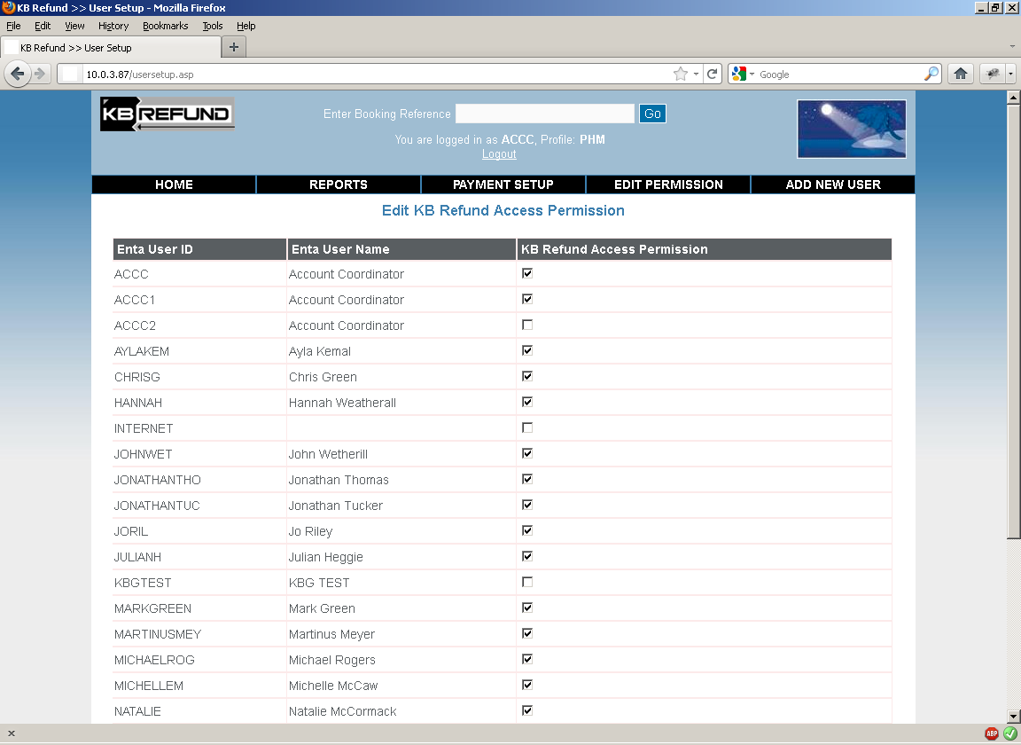
Figure 5 Valid Users

This screen shows the list of users who can login to KB Refund. If the checkbox is unticked, then that user can no longer access this application.

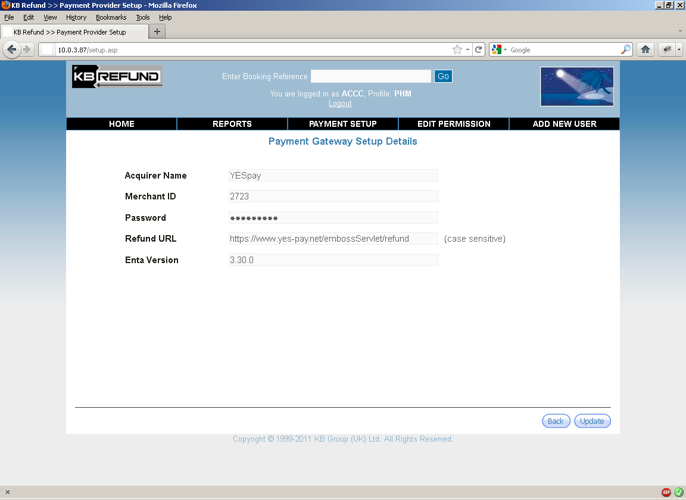
Figure 6 YESpay setup

This screen shows the YESpay setup.

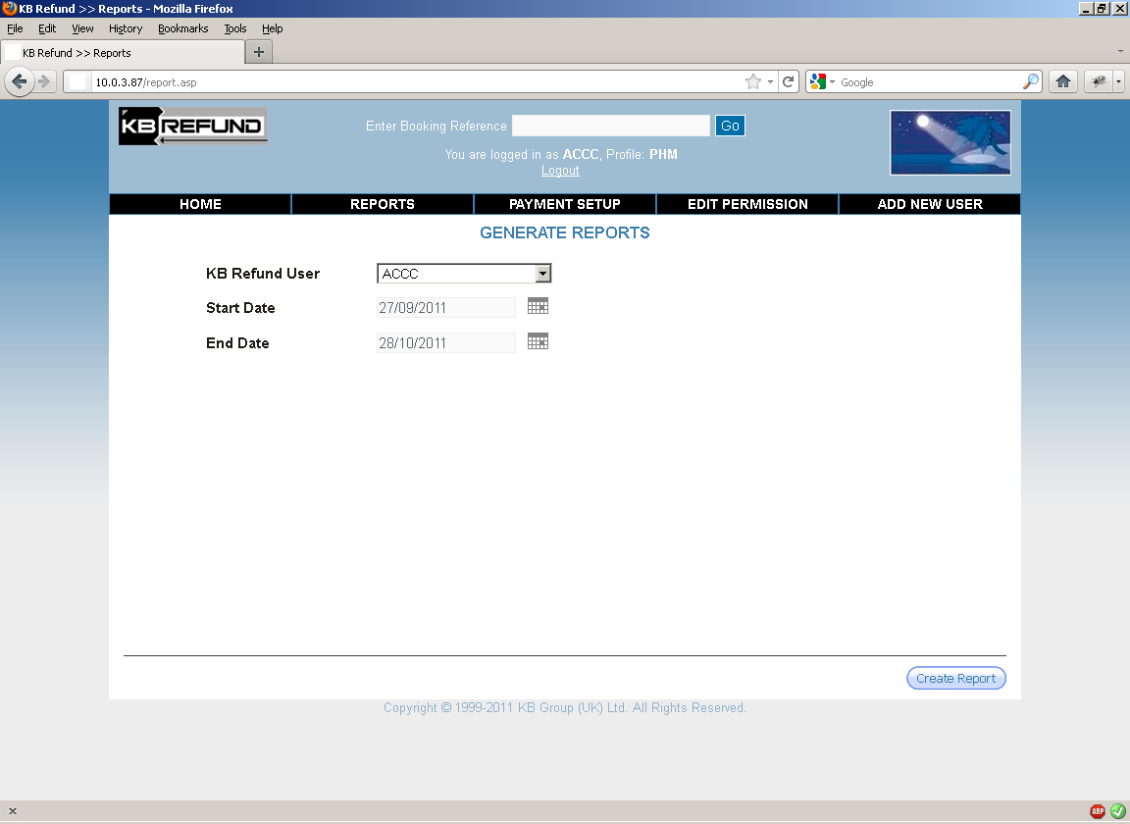
Figure 7 Reports

You can run reports against individual users to ascertain what refunds have been done.

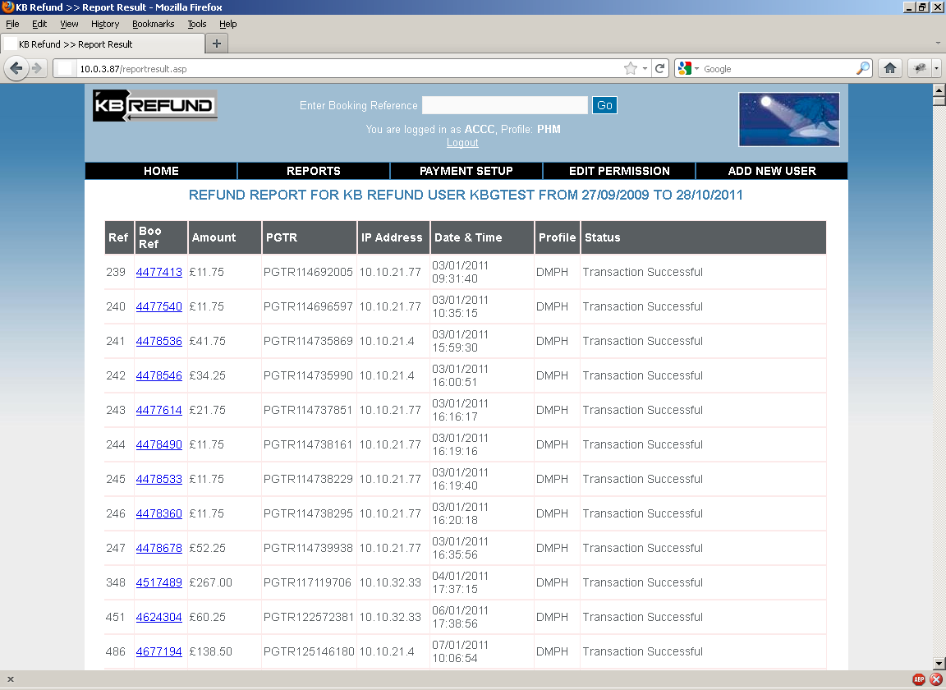
Figure 8 Report Results

This screen shows all the refund report results. Any refunds that failed are highlighted in Red.

Clicking the Booking Reference link takes you to the booking summary details page.

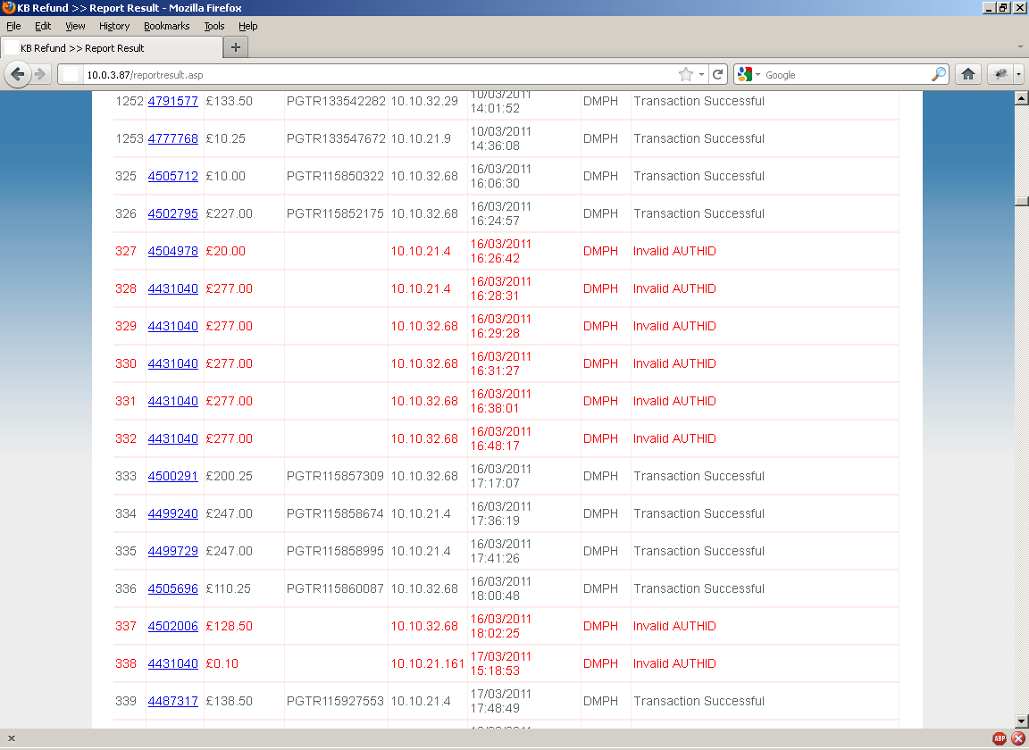
Figure 9 Report Showing Failed Refunds

This screen shot shows failed refunds and the reason why.

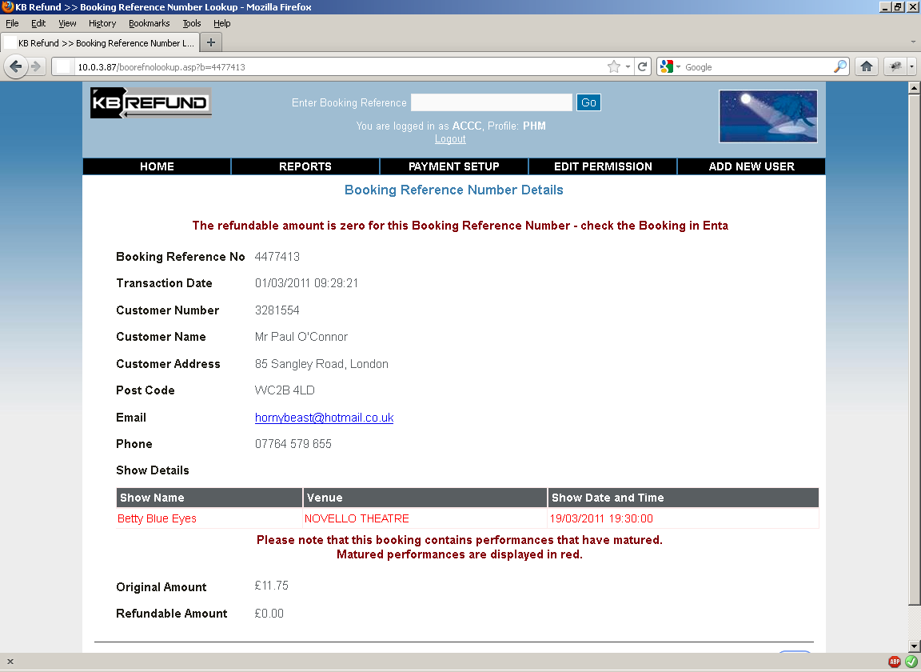
Figure 10 Refund Summary

This screen shot show the summary refund page detailing everything about the booking and the associated refund.

Matured performances are shown in Red.

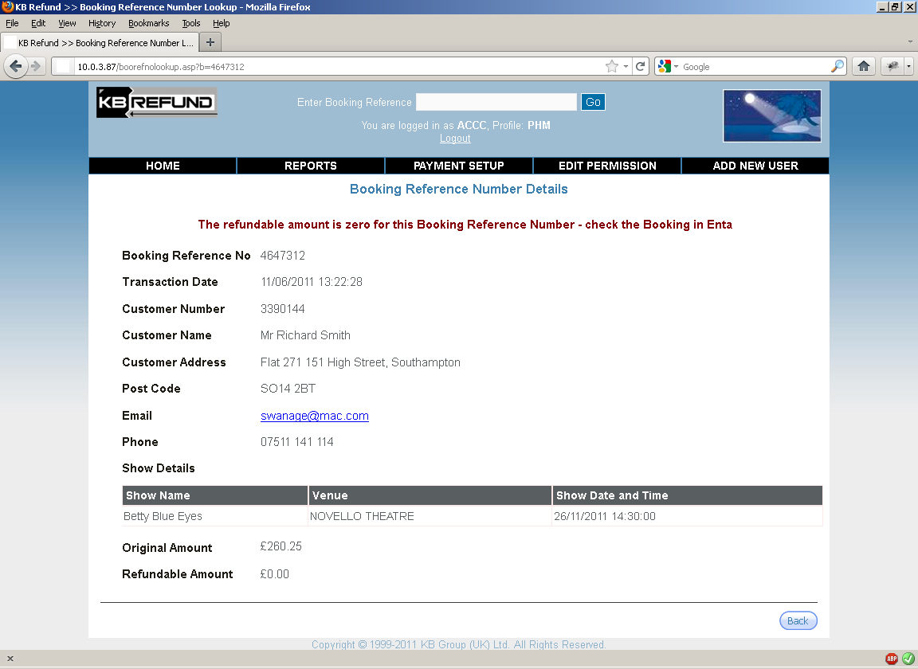
Figure 11 Refund Summary

This page shows a refund for a forthcoming performance.

