

KB Print Server Core Functionality
Do you want to?
- Reduce your printer purchase and maintenance costs by being able to purchase any Windows printer on the market. The Windows printer can be a serial, parallel, USB or network printer.
- No longer be limited to only using costly BOCA printers.
- Print tickets or membership cards to any Windows printer directly from your Back Office ticketing system.
- Use any installed Windows fonts and map them to the available GhostWriter fonts to produce much higher quality looking tickets.
- Print to two connected printers concurrently from the same workstation i.e. one printer for membership cards and another for without any effort from the operator.
- Print rotatable barcodes (with human readable details underneath e.g. BooRefNo) on your tickets or membership cards for admission control.
- Print additional information on tickets not currently available in Enta (such as membership issue numbers, second card holders, etc).
- Experience the KB Print Server high-speed spooler for queued job concurrency to enable rapid ticket or membership card printing.
- Have powerful status logging for any diagnostics.
- Have the same TCP printer topology as the Enta Ticket Servers so that KB Print Server works in a Citrix environment.
- Batch print selected groups of tickets, membership cards

KB Print Server Details
KB Print Server Setup overview
Below is a summary of the KB Print Server setup steps. A more detailed setup document is available.
- Obtain a KB Printer Server licence key for each work station that is using KB Print Sever
- Install KB Print Server licence key
- Install .net runtime
- Configure KB Print Server xml files (database and settings) and mark as read only
- Install Windows printer drivers for all Windows printers
- Install Code 128 AB tall fonts copy to fonts directory in Windows
- Ensure BOCA windows printer driver baud rate is set to 115k bps in print driver setup in Windows (if using serial cable)
- ODBC setup to match KB Print Server xml configuration settings
- Run KB Print Server setup.exe

KB Print Server Login
The KB Print Server Login Screen controls access to your Enta database by using your existing Enta logins.
- User Name: Enta username
- Password: Enta password
- Log on to: Drop down database selection menu
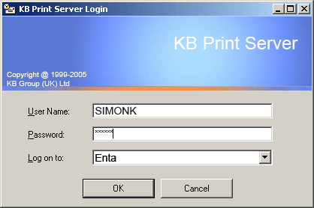

KB Print Server Settings
The KB Print Server Settings Screen allows you to configure your KB Print Server.
- Server Name: Workstation name
- Server IP Address: Workstation IP Address
- Connection Port: Connection to Enta
- Ticket Data Port: Connection to Enta
- Alternate Printer: Second printer
- Ticket Printer: Ticket printer
- Substitution Word: Identifies second printer
- Data Font: Ticket or membership card font
- Membership Description: Prints membership description
- Additional Benefits: Prints additional benefits
- Issue Number: Prints issue number
- Barcode: Prints barcode
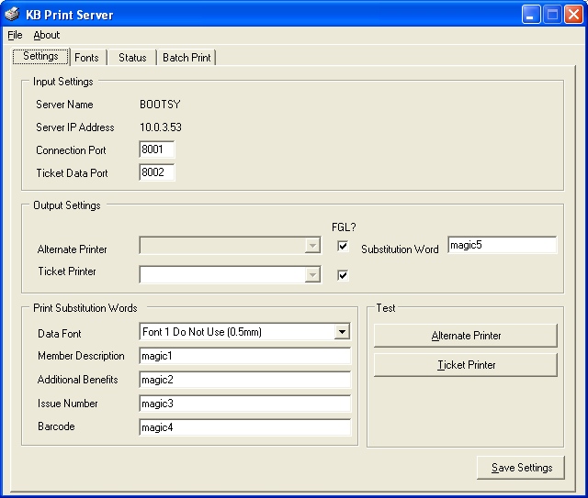

KB Print Server Status
The KB Print Server Status screen is a powerful diagnostic print status output screen.
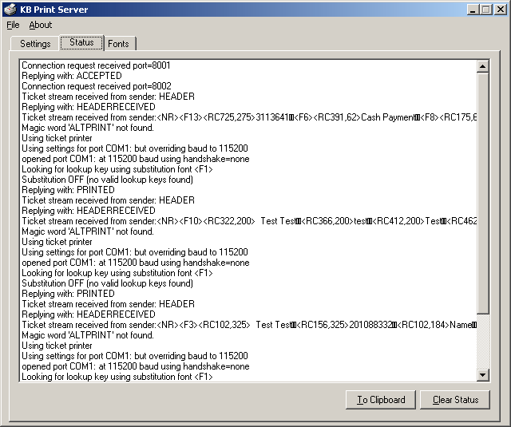

KB Print Server Fonts
The KB Print Server Fonts screen contains all of your installed customised fonts.
By mapping fonts in KB Print Server to the font capabilities in Enta you can customise your ticket layouts to use Windows True Type fonts. This means your tickets look significantly better than the fonts currently available through the BOCA printer. The end result is a much more professional looking ticket.
If your organisation uses a corporate font then this is the ideal mechanism for getting this font onto all your tickets.
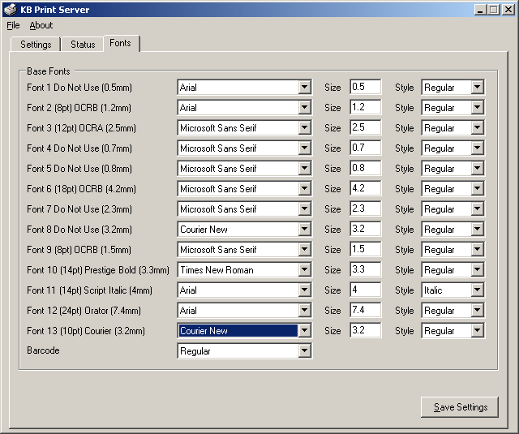

KB Print Server Batch Printing
The KB Print Server batch printing allows you to selectively print any quantity of unprinted bookings on demand. Simply create a list of booking reference numbers and then run the batch print function.
